Understanding the Microsoft Teams Meetings Link in Canvas
In Canvas, you can add a Microsoft Teams meetings link and Microsoft Teams classes link to the navigation menu. Both links are different, and this handout will focus on using the Microsoft Teams meetings link.

Microsoft Teams Classes
In Canvas, you can sync Microsoft Teams to the actual class team channel in Teams. Once you have done the sync, you will add a link to the navigation titled Microsoft Teams classes. The Microsoft Teams classes link provides a shortcut to the class team you activated in Microsoft Teams.

You can use the Microsoft Teams classes link to give live lectures/for virtual classes. So, if you will be using a class team channel, you can sync that team to your course and add a shortcut using the Microsoft Teams classes link in your Canvas course. To learn more about this, return to EDT’s Microsoft Teams support website and view the resource titled Setting up the Teams Meeting.

Microsoft Teams Meetings
In addition to the Microsoft Teams classes link, there is another link named Microsoft Teams meetings. This link is different than the classes link. The Microsoft Teams meetings is a separate meeting system from Microsoft Teams classes and provides a centralized place to locate all the stand-alone meetings (outside of the class team channel) for a course. The meetings on this page are not connected to the meetings scheduled in the Teams channels.

Therefore, we recommend that you do not schedule meetings in both. Choose one of the two to have virtual sessions. If you want to have stand-alone meetings, such as one-on-one meetings with a student, you can use the Microsoft Teams meetings page to create the meeting and invite the student to the meeting. By doing it this way, the student can locate the meeting in the course and on their calendar. Remember, only the invited individuals will be able to see the meetings on the Microsoft Teams meetings page. If you want to have a virtual class session, we recommend using the Teams channel.

If you create a meeting on the Microsoft Teams meetings page and invite individuals, the meeting will appear on your calendar along with the individual(s) you invited Teams calendar and Outlook calendar. If the meeting is recorded, whomever presses the record button is the owner of the recording and can locate the recording in their OneDrive account.

If you create a meeting on Microsoft Teams meetings page and don’t invite the individual, it will only show on the Microsoft Teams meetings page for you and only appear on your calendar. So, if you want someone to attend, you will need to invite them.

Adding Microsoft Teams Meetings to Your Canvas Course
- Access your Canvas course.
- Click Settings from the left-hand menu.
- Click the Navigations tab.
- Move Microsoft Teams meetings up from the bottom group to the top group.
- Click Save.
- Click Microsoft Teams meetings from the left-hand navigation menu.
- You may be prompted to sign into Teams from within Canvas. If so, click Sign in and follow the onscreen prompts.
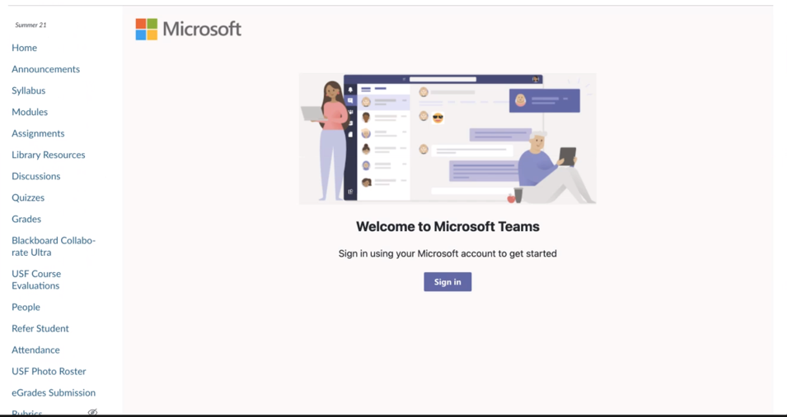
Step 7

- After you have signed in, you will see all stand-alone meetings you have created. We recommend that you verify the individuals you have invited for each meeting.

Joining Microsoft Teams Meetings from Canvas Course
- Access your Canvas course.
- Click Microsoft Teams meetings from the left-hand navigation menu.
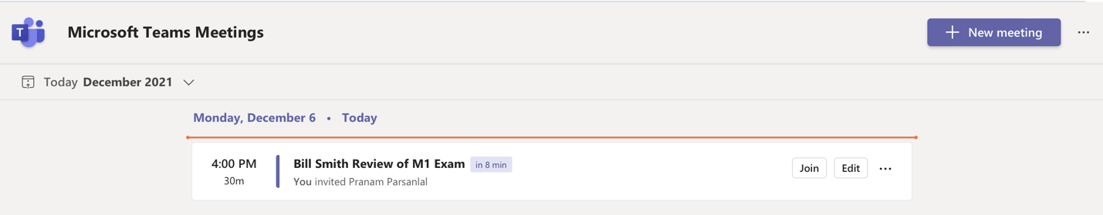
- Click Join for the meeting you wish to join and follow the onscreen prompts.
Step 3

